**L298N Dual H Bridged Motor Controller**

**Introduction:-**

It is used to control the motors of the car as well as like Relay for 3.3V to 9V and above.

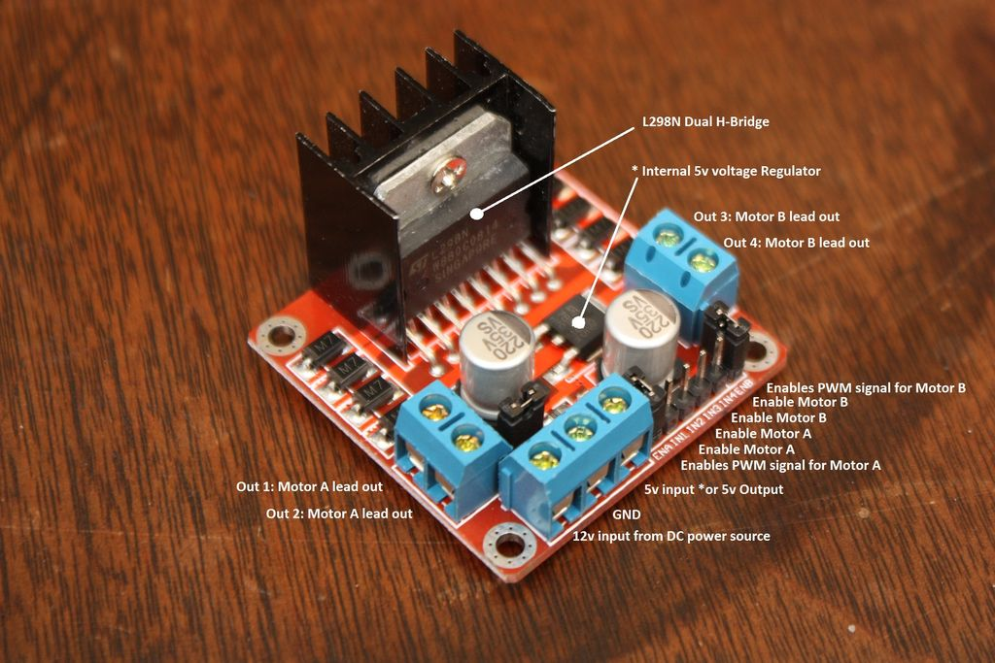

Fig No. 5

**Pins:**

* Out 1: Motor A lead out
* Out 2: Motor A lead out
* Out 3: Motor B lead out
* Out 4: Mo (*Can actually be from 5v-35v, just marked as 12v*)
* GND: Ground
* 5v: 5v input (*unnecessary if your power source is 7v-35v, if the power source is 7v-35v then it can act as a 5v out*)
* EnA: Enables PWM signal for Motor A (Please see the "Arduino Sketch Considerations" section)
* In1: Enable Motor A
* In2: Enable Motor A
* In3: Enable Motor B
* In4: Enable Motor B
* EnB: Enables PWM signal for Motor B (Please see the "Arduino Sketch Considerations" section)

**Specifications:**

* Double H bridge Drive Chip:*L298N*
* Logical voltage: *5V Drive voltage: 5V-35V*
* Logical current: *0-36mA Drive current: 2A (MAX single bridge)*
* Max power: *25W*
* Dimensions: *43 x 43 x 26mm*
* Weight: *26g*

**Working-**

* 1. We have used two motors to make the car multidirectional and a roller in the front to just for balance the load and rolling smoothly.
  2. If we have used only one motor then the car would move just forward and backward or left and right.
  3. If both wheels will rotate forward then car will move forward and if both move in backward direction then car will move in backward.
  4. If the left wheel will be in stop position and right wheel will moving forward the car will move in left direction.
  5. If the right wheel will be in stop position and left wheel will moving forward the car will move in right direction.

**Dual H bridge**

An **H bridge** is an electronic circuit that enables a voltage to be applied across a load in opposite direction. These circuits are often used in robotics and other applications to allow DC motors to run forwards or backwards.

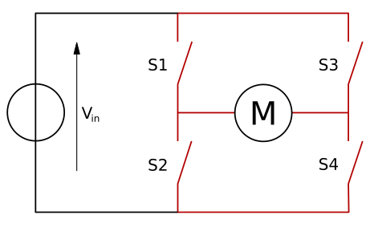

Fig No. 6